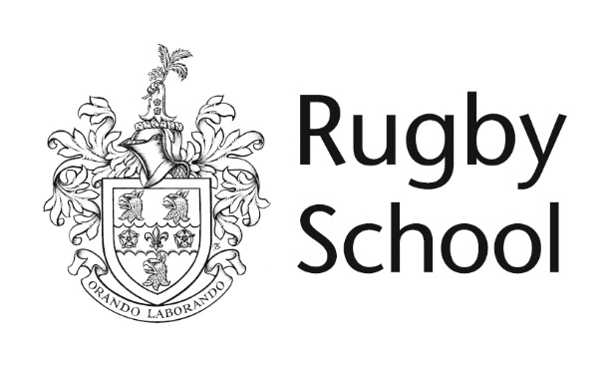

**Sixth Form Entrance Examination**

**ENGLISH**

***Time allowed: 1 hour***

**Instructions to candidates:**

This paper consists of 2 sections.

You must answer **1 question in section A (comprehension) and 1 question in section B (writing task)** on lined paper.

Equipment Required: **Pen.**

There are **100 marks** available in total.

Name: _______________________________________________

**SPECIMEN**

**SECTION A: COMPREHENSION (30 minutes)**

The Awakening *focuses on Edna Pontellier, a wife and mother whose views grate against the more orthodox attitudes of the American Deep South in the late 1800s.*



**Comprehension**

* *Spend 5 minutes reading (and re-reading) the passage carefully, before answering the question below.*
* *Be sure to structure your work and support your points with quotations from the passage.*

1. What are your initial impressions of Edna Pontellier in this passage? Consider who she is talking to, what she is talking about and why it is important.

**(50 marks)**

**SECTION B: ESSAY (30 minutes)**

* *Be sure to structure your work; use a varied vocabulary; use accurate spelling and punctuation. Above all, be bold and imaginative in your writing choices.*
* *You are advised to spend 5 minutes planning your response.*

Write an essay on ONE of the following titles:

1. ‘Making her eyes burn’.

Continue the story from here.

1. Write a story entitled ‘Oh, if only you knew!’.
2. Write about a time when you did something unorthodox, and explain why this experience felt significant.

**(50 marks)**

**Total: 100 marks**

**END OF EXAMINATION**