Sixth Form Entrance Examination

CLASSICAL GREEK
Time allowed: 1 hour

Instructions to candidates:

This paper consists of 2 sections. You must answer all of the questions in BOTH sections on lined paper.

Equipment Required: Pen, pencil, lined paper.

There are 65 marks available in total.

Name: _______________________________________________

Section 1: Comprehension and Translation

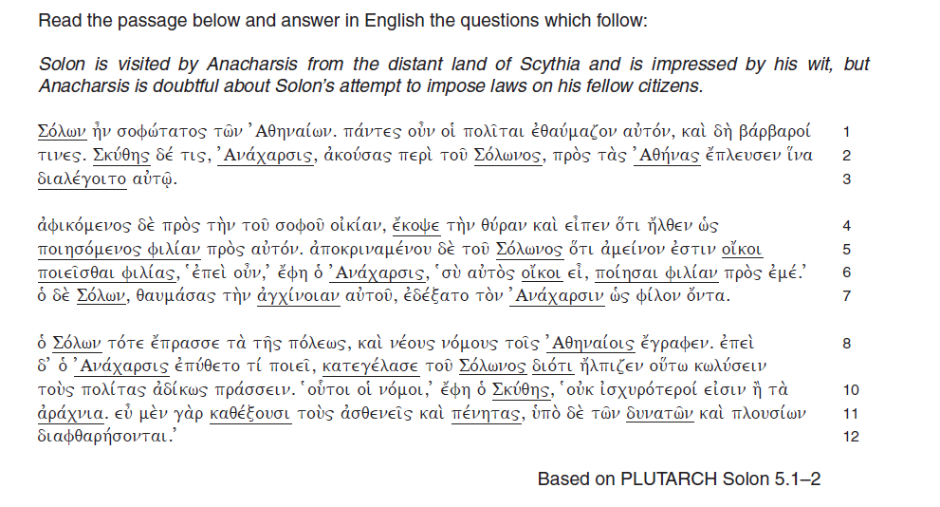

- Answer the questions below. [15]
- Translate the last paragraph of the text on alternate lines. [20]

Section 2: Translation from English into Greek [15]

Section 3: Literary Criticism
Answer the style question below. [15]

Ἐν δὲ τῷ πόνῳ τούτῳ ἀπέθανε μεν ὁ στρατηγὸς Ἀριαβίγνης ὁ Δαρείου, Ξέρξου ὤν ἀδελφός, ἀπέθανον δὲ ἄλλοι πολλοί τε καὶ ὀνομαστοὶ Περσῶν τε καὶ Μήδων καὶ τῶν ἄλλων συμμάχων, ὀλίγοι δὲ τινὲς Ἑλλήνων• ἅτε γὰρ νεῖν ἐπιστάμενοι, εἰς τὴν Σαλαμῖνα διένεον, εἴ τισιν αἱ νῆες διεφθειροντο• τῶν δὲ βαρβάρων οἱ πολλοὶ ἐν τῇ θαλάττῃ διεφθάρησαν, νεῖν οὐκ ἐπιστάμενοι. ἐπεὶ δὲ αἱ πρῶται νῆες εἰς φυγὴν ἐτράποντο, ἐνταῦθα αἱ πλεῖσται διεφθείροντο• οἱ γὰρ ὄπισθε τεταγμένοι, εἰς τὸ πρόσθεν παριέναι ταῖς ναυσὶ πειρώμενοι ὡς ἀποδειξό- μενοί ἔργον τι καὶ αὐτοὶ βασιλέι, ταῖς ἄλλαις ναυσὶ ταῖς φευγούσαις περιέπιπτον.
In this struggle the general Ariabignes died, son of Darius and the brother of Xerxes. Many other famous men of the Persians and Medes and other allies also died, but only a few Hellenes, since they knew how to swim. Those whose ships were sunk swam across to Salamis, unless they were killed in action, but many of the barbarians drowned in the sea since they did not know how to swim. Most of the ships were sunk when those in the front turned to flee, since those marshalled in the rear, as they tried to go forward with their ships so they too could display some feat to the king, ran afoul of their own side's ships in flight.
Herodotus, Hist. 8.89
How does Herodotus vividly convey the complete defeat of the Persians?
In your answer you should use Greek to support.
Total [65]
End of Paper.

