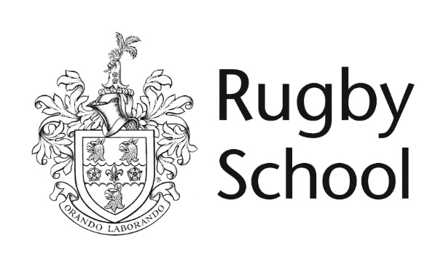

Modern Languages

Sixth Form Examination

Mark Scheme

Sixth Form Specimen Examination Mark Scheme
Modern Languages

Mark Schemes

Writing (30)

Content (15)

10-15 | Imaginative, interesting and entertaining work. The candidate exploits the question and its implications fully, coming up with a thoughtful and imaginative response.
5-9 | A good response covering the main point and implications of the question. A range of clear points.
0 -4 | Some details are communicated but mistakes sometimes interfere with the intended message. Communication is incomplete with few extra details.

Quality of Language (15)

10 – 15 | A full range of tenses is used accurately. Adjectives and adverbs are employed consistently. Language is highly accurate and sometimes goes beyond what is expected at GCSE level.
5-9 | Language used is generally accurate and past, present and future tenses are secure. Errors might be expected in more ambitious language but common structures and phrases are correct.
0-4 | There is a noticeable degree of inaccuracy and tenses are incorrectly used or formed. Language is accurate enough to communicate a message using appropriate vocabulary and structures.

Speaking (for those attending interview)

S | The candidate copes with a wide range of topics and can interact with the interviewer spontaneously. Language and accent and highly accurate. The candidate can lead the conversation.
A | A very good performance on the whole. Unexpected questions may cause difficulties but language is generally accurate.
B | A good performance despite some inaccuracy and lack of fluency. The candidate can communicate a clear message despite some misunderstanding.
C | A sound performance but with a greater amount of inaccuracy and with more frequent problems of communication.

